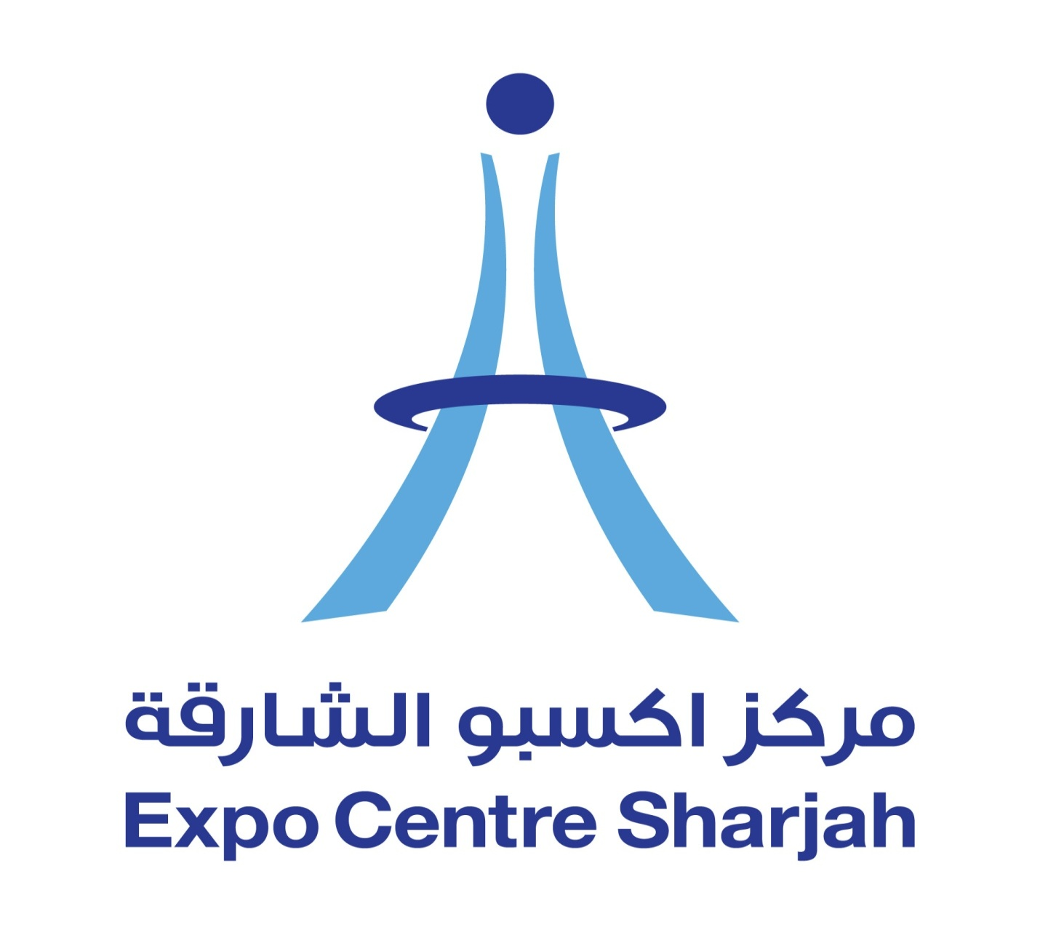

SPONSORSHIP OPPORTUNITIES
15th GCC EXPO 2014

Why sponsor the 15th GCC EXPO 2014?
- Sponsorship impacts on the visitor more powerfully than any other marketing tool
- Sponsorship is a direct and cost-effective route straight to your target market

The 15th GCC EXPO 2014sponsorship offers you the opportunity to:
- Meet over 10,000 potential qualified customers all in one place over a 5 day period
- Ensure high-impact visibility by being part of our extensive promotional campaign
- Position your company as a market leader and increase your chance to win business in the UAE
- Raise brand awareness of your products and services

PLATINUM SPONSOR
15th GCC EXPO
26 – 30 May 2014
Expo Centre Sharjah

What Platinum Sponsorship has to offer:
- As the Platinum Sponsor of 15th GCC EXPO 2014, SPONSOR brand will have the highest level of visibility and exposure as part of this exciting high profile and popular show.
- SPONSOR, as the exclusive Platinum Sponsor of the 15th GCC EXPO 2014 will receive the following:-
- Logo to appear on all promotional materials to include but not limited to:-

SPONSORS logo on internal ECS Show branding to include:
- Hall hanging show banners (1.5m x 4m) minimum 4
- Boulevard banners (1m x 2.5m) minimum 5
- Welcome boards at both entrances (2m x 2.5m)
- 10 x directional footprints leading to your stand
- Hall 5 entrance banner leading from boulevard (14m x 2.8m)
- Registration counter stickers Al Taawun entrance (.82 x 10.3m) x 2
- SPONSOR pop-up banner (.85m x 2m) to be placed in the main registration area (artwork to be provided by SPONSOR and printed by Expo Centre)
- SPONSOR will be entitled for 4 additional banners (.85m x 2m) to be displayed at the central boulevard and 1 banner in each hall (artwork to be provided by SPONSOR and printed by Expo Centre)

SPONSORS logo on all show media (preceded by title of 'Platinum Sponsor')
- Logo on exhibitor promotional brochure to include:
- Press release announcing SPONSOR exclusive Platinum Sponsorship status of the show
- Show catalogue - logo on front cover
- Show catalogue - full colour DPS
- Show web site - dedicated page and hyperlink to SPONSOR site
- Web site - logo to appear on each page as platinum sponsor
- Logo to appear on all social media to include twitter, Facebook, Linkedin etc.
- Logo on all promotional e-casts (both exhibitor and visitor promotion)
- Logo on all printed media to include newspaper advertising
- Logo on VIP opening invitations
- SPONSOR support recognized in all press materials, releases and email broadcasts (printing is not guaranteed)
- 2 x dedicated e-casts to either exhibitors or visitors to promote your key messages - one prior to and one post event

SPONSORS logo on external show branding
- Ad Nahda hoarding (30m x 8m)
- A-boards x 10 (2.44m x 1.22m)
- Mupi's around the perimeter of the venue x 15 (1.16m x 1.66m)
- Lamppost banners x 20 located around Al Taawun area (1.2m x 2.4m)
- Flags located in front of Al Taawun roundabout x 7 (1m x 6m)
- Additionally, SPONSOR will be offered a prime location exhibition stand space of 36sqm. This will be a space only stand for your own free build area.

Total Platinum Sponsorship package cost: AED 200,000

GOLD SPONSOR
15th GCC EXPO
26 – 30 May 2014
Expo Centre Sharjah

What Gold Sponsorship has to offer:
- As the Gold Sponsor of 15th GCC EXPO 2014, SPONSOR brand will have the highest level of visibility and exposure as part of this exciting high profile and popular show.
- SPONSOR, as the Gold Sponsor of the 15th GCC EXPO 2014will receive the following:-
- Logo to appear on all promotional materials to include but not limited to:-

SPONSORS logo on internal ECS Show Branding to include:
- Hall hanging show banners (1.5m x 4m) minimum 2
- Boulevard banners (1m x 2.5m) minimum 2
- Welcome boards at both entrances (2m x 2.5m)
- 1 x SPONSOR pop-up banner (.85m x 2m )to be placed in the main registration area (artwork to be provided by SPONSOR and printed by Expo Centre)
- SPONSOR will be entitled for 2 additional banners (.85m x 2m )to be displayed at the central boulevard

SPONSORS logo on all show media (preceded by title of 'Gold Sponsor')
- Logo on exhibitor promotional brochure to include:
- Show catalogue - full colour single page advert
- Show web site - one dedicated page and hyperlink to SPONSOR site
- Web site - logo to appear on front page as gold sponsor
- Logo to appear on all social media to include twitter, Facebook, Linkedin etc.
- Logo on all promotional e-casts (both exhibitor and visitor promotion)
- Logo on all printed media to include newspaper advertising
- SPONSOR support recognized in all press materials, releases and email broadcasts (printing is not guaranteed)
- 1 x dedicated e-casts to either exhibitors or visitors to promote your key messages - one prior to and one post event

SPONSORS logo on external show branding
- Al Nahda hoarding (30m x 8m)
- A-boards x 10 (2.44m x 1.22m)
- Mupi's around the perimeter of the venue x 7 (1.16m x 1.66m)
- Flags located in front of Al Taawun roundabout x 5 (1m x 6m)
- Additionally, SPONSOR will be offered a prime location exhibition stand space of 24sqm. This will be a space only stand for your own free build area.

Total Gold Sponsorship package cost: AED 150,000

SILVER SPONSOR
15th GCC EXPO
26 – 30 May 2014
Expo Centre Sharjah

What Silver Sponsorship has to offer?
- As the Silver Sponsor of 15th GCC EXPO 2014, SPONSOR brand will have the highest level of visibility and exposure as part of this exciting high profile and popular show.
- SPONSOR, as the Silver Sponsor of the 15th GCC EXPO 2014will receive the following:-
- Logo to appear on all promotional materials to include but not limited to:-

SPONSORS logo on internal ECS Show Branding to include:
- 1 piece Hall hanging show banners (1.5m x 4m)
- 1 piece Boulevard banners (1m x 2.5m)
- 1 x SPONSOR pop-up banner (.85m x 2m )to be placed in the main registration area (artwork to be provided by SPONSOR and printed by Expo Centre)
- SPONSOR will be entitled for 2 additional banners (.85m x 2m )to be displayed at the central boulevard

SPONSORS logo on all show media (preceded by title of 'Silve Sponsor')
- Logo on exhibitor promotional brochure to include:
- Show catalogue - full color single page advert
- Show web site - one dedicated page and hyperlink to SPONSOR site
- Web site - logo to appear on front page as gold sponsor
- Logo to appear on all social media to include twitter, Face book, LinkedIn etc.
- Logo on all promotional e-casts (both exhibitor and visitor promotion)
- Logo on all printed media to include newspaper advertising
- SPONSOR support recognized in all press materials, releases and email broadcasts (printing is not guaranteed)
- 1 x dedicated e-casts to either exhibitors or visitors to promote your key messages - one prior to and one post event

SPONSORS Logo on external show branding
- Al Nahda hoarding (30m x 8m)
- A-boards x 10 (2.44m x 1.22m)
- Mupi's around the perimeter of the venue x 7 (1.16m x 1.66m)
- Flags located in front of Al Taawun roundabout x 5 (1m x 6m)
- Additionally, SPONSOR will be offered a prime location exhibition stand space of 18sqm. This will be a space only stand for your own free build area.

Total Silver Sponsorship package cost: AED 100,000

