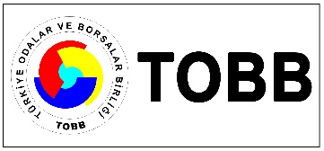
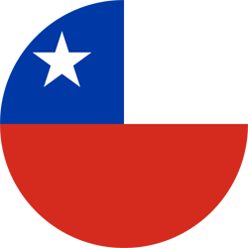
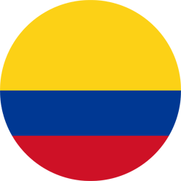

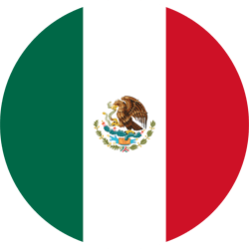

BUSINESS OPPORTUNITIES IN PACIFIC ALLIANCE:
TURKEY, PERU, CHILE, COLOMBIA, MEXICO
TOBB, 6 NOVEMBER 2018

NAME-SURNAME
COMPANY NAME
POSITION
FIELDS
BUSINESS WITH PERU, CHILE, COLOMBIA, MEXICO
TEL
E-MAIL

