 |  |  | 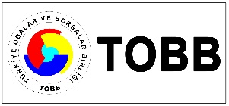
TURKEY-CANADIAN BUSINESS FORUM
ANKARA, TOBB HEADQUARTERS
15 NOVEMBER 2019
DRAFT AGENDA

10.00 – 14.00 | BUSINESS OPPORTUNITIES BETWEEN TURKEY AND CANADA
10.00 - 10.30 | Registration  Venue: TOBB Sosyal Tesisler Hall 1-2-3, 3rd Floor
10.30 – 11.00 | Opening remarks:  Moderator:  - TOBB  - Hon Gar Knutson, PC, Chair of Canadian Turkey Business Council  - Canadian Embassy to Ankara
11.00-11.30 | Plenary Session:  - Introduction of the Participants  - Economy of Turkey, TEPAV  - Investment and Incentive Opportunities of Turkey, Ministry of Trade
11.30 - 11.45 | Q & A
11.45 – 13.00 | Sectoral Breakout Sessions and B2B Meetings
13.00-14.00 | Lunch
14.00 | Closure

Hazırlayan: Seda Gedik

