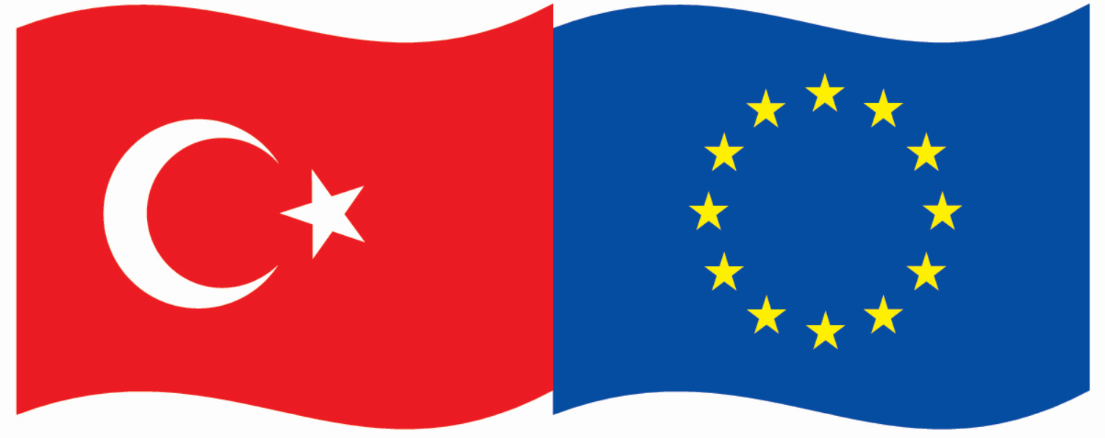

This project is co-funded by the European Union and the Republic of Turkey



**Energy Efficiency Activity**

**CALL FOR CANDIDATES**

**The Turkey-EU Business Dialogue (TEBD) project**

The **Turkey-EU Business Dialogue** (TEBD) is a project co-funded by the European Union under its IPA II programme with Turkey. TEBD is managed by [EUROCHAMBRES](http://www.eurochambres.eu/), through a grant contract with [CFCU](http://www.cfcu.gov.tr/), in close cooperation with [TOBB](http://www.tobb.org.tr/), as the end beneficiary institution of the project. The TEBD activities are implemented through the European and Turkish Chambers of Commerce and Industry.

The overall objective of the project is to strengthen mutual knowledge and understanding between Turkish Chambers and their counterparts in the EU, thus promoting the integration of EU and Turkish business communities and ensuring a stronger awareness of the opportunities and challenges of a potential future Turkey’s accession to the EU in both Turkey and the EU.

The TEBD project wants to promote a constructive private sector dialogue between the EU and Turkey that will lead to positive and lasting results for both sides.

**The Energy Efficiency Activity**

One of the components of the TEBD Project is called Capacity Building. This component aims to build capacities of Chamber executives by a variety of tools and activities that include a dedicated Chamber Academy, Study Visits, and proven support tools for SMEs such as Acquis-, Energy Efficiency, Solvency Audits.

Following the EU Acquis Audit and the EU Solvency Audit activities, a third “service” will be developed in the project, the ***Energy Efficiency*** *activity.*

The objective of this activity is to develop capacity and knowledge within Turkish Chambers, which will allow them to advise SMEs/members on how they can reduce their energy consumption, and thus become more competitive and raise the awareness on Energy Efficiency.

An online training will be organised for 25 Turkish chamber executives selected by TOBB and EUROCHAMBRES. Executives will be selected from across the country (regional spread) and following the competences profile criteria that will be explained in the following section of the Call for Participants. The training will be delivered by the network experts of EUROCHAMBRES and TOBB. Following to the Module 2, “Energy Efficiency Help Desk” will be developed in the 25 Turkish Chambers.

The Energy Efficiency activity will take place between May and July 2021, and it will consist on:

1. Module 1(May 2021)

Online Training on how to use the Energy Efficiency Toolkit, understanding the different sections, data collection, identification of opportunities and referral points for further exploration.

1. Module 2 (June – July 2021)

Outreach by Turkish Chamber experts to SMEs, with EU experts providing advice and consultation to the Turkish Chamber experts

1. Module 3 (July – August 2021)

Preparation of a report by the EU experts, summarising the Energy Efficiency situation among SMEs, and making policy and technical recommendations for further actions based on the inputs by the Turkish Chamber participating.

The Online training (Module 1) will be organised in 2 different sessions:

* Training 1: as two-day seminar – 5 hours/day (**4 & 5** **May 2021**)
* Training 2: as two-day seminar – 5 hours/day (**25 & 26** **May 2021**)

Following this training, each Turkish Chamber will commit to carry out 10 energy efficiency visits (all online) among different Turkish companies using the Toolkit. The total target is therefore 250 Turkish Companies visited. The TEBD Team, with the support of experts, will be in contact with each Turkish Chamber to complete the visits.

Following the completion of these visits using the Toolkit, a general Energy Efficiency Report will be drafted by each Chamber participant, providing a comprehensive overview of the potential for further energy efficiency actions within Turkish companies.

**Participation requirements**

You can participate in the Energy Efficiency activity if you meet the following competences.

Compulsory competences:

* Degree of Higher Education (preferably in Business Administration,  Economics, Engineering or equivalent)
* They must be practitioners who work directly with companies, not management-level or administrative staff
* A minimum experience of 12 months in providing support to SMEs. Alternatively to possess a proven record of owing and/or managing a company,
* They must have basic knowledge of energy management and/or facility and operations management in SMEs
* They must have good understanding of the decision making process in SMEs, including in deciding to opt for equipment or facility upgrades
* They must have solid knowledge of the financing of SME operation: What is possible, what is not?
* Ability/competence to quickly identify problems and opportunities in equipment, process, and facilities
* They must understand business or project plan development and be capable of pitching such projects, identifying critical criteria
* Be methodological and data-driven persons, capable of using standardised tools while remaining open to identifying and adapting to case-specific requirements
* Full fluency in written and spoken English

Preferable competences:

* Experienced in consultancy
* Interested in topics like energy efficiency, renewable energies, developments in the energy market, environment, sustainability

Up to **25 Turkish Chamber executives** can participate in the TEBD Energy Efficiency activity.

**Role as a participating Turkish Chamber expert**

* Attend the 2 training sessions.
* Further to the training sessions, you will promote the Energy Efficiency visits among Turkish companies in your Chamber.
* Further to this information campaign, you will select 10 companies in your region to contact them, and get the information needed for the analyses of the situation (all this process will be manage ONLINE).
* You will then contact the companies, go through the toolkit and verify, all the questions raised during the training. For each assistant you will have the constant support of the EU experts.
* On the basis of the results and supported by the EU experts, you will provide us with a document/report on the different cases you assisted.
* On the basis of the reports of all the Turkish experts, the EU Experts with the support of EUROCHAMBRES & TOBB will draft the Energy Efficiency final report.

**Financial & Technical information**

Based on the format of the activity, that will take place online, no expenses (travel, accommodation, hotel, meals, personal expenses, etc) will be borne by the TEBD Project.

EUROCHAMBRES will provide the online platform which will be used during the entire activity, and basic remote technical assistant linked to the online platform will be also provided to the participants.

**How to apply?**

If you are interested in participating in the TEBD Energy Efficiency Activity, please submit your application form by email to Ángela Ustárroz ([ustarroz@eurochambres.eu](mailto:ustarroz@eurochambres.eu)) by **Monday 12th April 2021, 4.00pm Brussels time**, at the latest.

Participants will be selected on the basis of the criteria mentioned above, and the questions included in the application form. Selected participants will be notified by 27th April 2021, and receive an official confirmation letter.

**Participants will be required to mandatory attend all the training sessions indicated before and complete all the visits, moreover provide the reporting document to the EU Experts. In case any participant do not fulfill any of the mentioned responsibilities, he/she won’t be able to participate in any other TEBD Project Activity.**

**APPLICATION FORM**

Turkey-EU Business Dialogue (TEBD) – Energy Efficiency activity 2021

Virtual Activity – May 2021 - July 2021

**Please, fill in the document by typewriter**

Deadline: Monday 12th April 2021 (4:00pm)

|  |  |
| --- | --- |
| **Last Name** |  |
| **First Name** |  |
| **Position** |  |
| **Your Chamber** |  |
| **Address** |  |
| **Email** |  |
| **Direct Office Phone** |  |
| **Mobile Phone** |  |
| **Chamber Twitter Account** |  |
| **Chamber Facebook Account** |  |
| **English Knowledge** | **Yes / No** |

**Questions below will be used as a reference in the selection process.**

**The TEBD team may ask for additional information if required.**

**A. YOUR ORGANISATION**

Please describe briefly the main features of your Chamber: (i) Profile of your Members (ii) Internal structure and (iii) Main activities (max 15 lines).

|  |
| --- |
|  |

**B. YOUR BACKGROUND**

Please explain your personal background (short CV): studies, professional experience in the theme, role in the Chamber (max 10 lines).

|  |
| --- |
|  |

**D. CONSULTANCY KNOWLEDGE**  
Please indicate if you have a concrete knowledge or experience in supporting SMEs in the mentioned field.

**C. YOUR MOTIVATION**

Please explain in detail why you wish to participate in the Energy Efficiency activity and which benefits of your participation will bring to your Chamber in the short and long run (max 15 lines).

|  |
| --- |
|  |

Signed: ______________________________ Date:____________________________

**MORE INFORMATION**

Please contact Ángela Ustárroz [ustarroz@eurochambres.eu](mailto:ustarroz@eurochambres.eu)

Tel +32 2 282 08 79