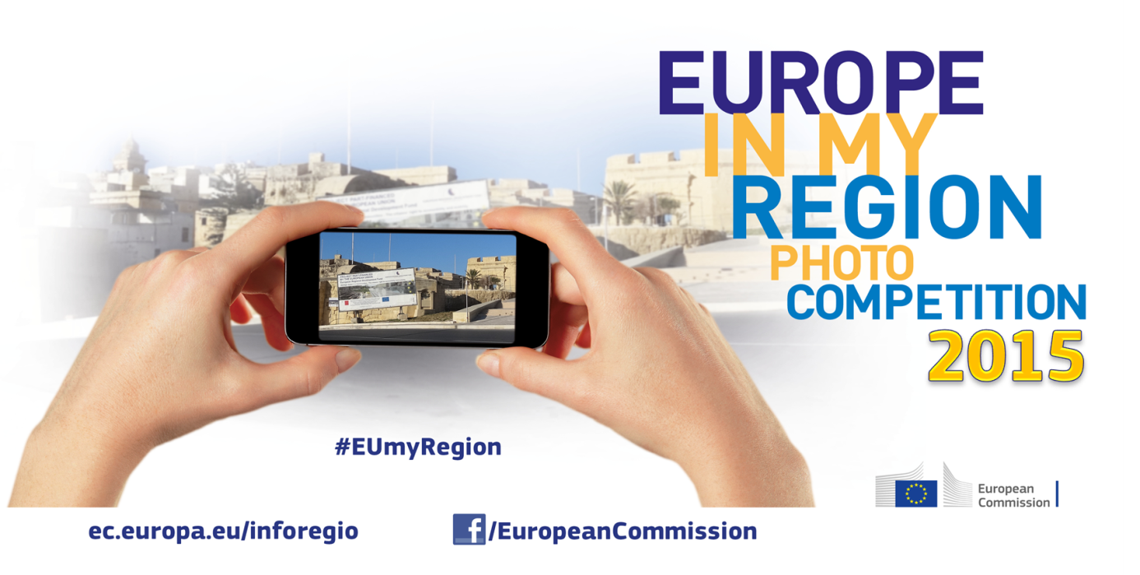
Europe in My Region Facebook photo competition starting 22/6/2015
The annual ‘Europe in My Region’ Photo Competition, now in its fourth year, takes place this summer and once again aims to raise awareness of projects which have received funding as part of EU regional policy. This year participation in the competition has been extended to include residents in pre-accession countries: Albania, Bosnia and Herzegovina, the former Yugoslav Republic of Macedonia, Kosovo, Montenegro, Serbia, and Turkey).
As before, the competition is run via the European Commission’s corporate Facebook page (https://www.facebook.com/EuropeanCommission/app_386310531430573 ). The competition will be launched on June 22th and entries will be accepted until Friday 28 August 2015 (at noon Central European Summer Time). The 100 pictures with the highest amount of votes, plus up to 50 “wildcard” entries (that were not included in the 1st group with the highest votes), are put forward to a jury of 3 photography professionals who will select 3 winners. The winners will be awarded with a trip for two to Brussels during the OPEN DAYS 2015 in October.
For information, take a look at last's year entries: https://www.flickr.com/photos/euregional/sets/72157648215374403.
[Regio FB page: https://www.facebook.com/EUinmyregion]
Hashtag: #EUmyRegion
Email: regio-infopub@ec.europa.eu

We need your help to get more visibility and shares, by using the official hashtag of the competition #EUmyRegion whenever you talk / share it.
THANK YOU !

KEY DATES Facebook posts on EC corporate Facebook page
Date | Day | Time CET | Boost posts | Topic
16-Jun | Tuesday | 12:00 |  | "Competition to start on 22/06"  posted on https://www.facebook.com/EUinmyregion
22-Jun | Monday | 12:00 | X | Competition kickoff
26-Jun | Saturday | 11:45 |  | EU funding [all funds]
29-Jun | Wednesday | 14:45 |  | EU Regional policy budget
2-Jul | Tuesday | 14:15 |  | Hashtag sharing and number of photo entries
10-Jul | Friday | 15:25 | X | Competition halfway [all funds]
16-Jul | Thursday | 15:00 |  | Trip to Brussels and EU Open Days [all funds]
22-Jul | Wednesday | 16:00 |  | Photo story [all funds]
28-Jul | Tuesday | 14:00 |  | Received entries [n° ] from all over Europe [all funds]
1-Aug | Saturday | 10:00 | X | Raising awareness about EU's support to local projects [all funds -city,seaside,countryside,mountain]
6-Aug | Thursday | 14:40 |  | Pre-accession countries
14-Aug | Thursday | 14:00 |  | Entries selection and voting
21-Aug | Friday | 15:50 | X | One week left to enter
28-Aug | Monday | 12:00 |  | Competition closure [>Pinterest board]
31-Aug | Wednesday | 12:00 | X | Voting starts [first 100 + 50 wildcards enter jury vote]
8-Sept | Tuesday | 12:00 |  | Voting ends
19-Sept | Saturday |  |  | Three winners will be announced
13-Oct | Tuesday |  |  | Ceremony awards during EU Open Days in Brussels

