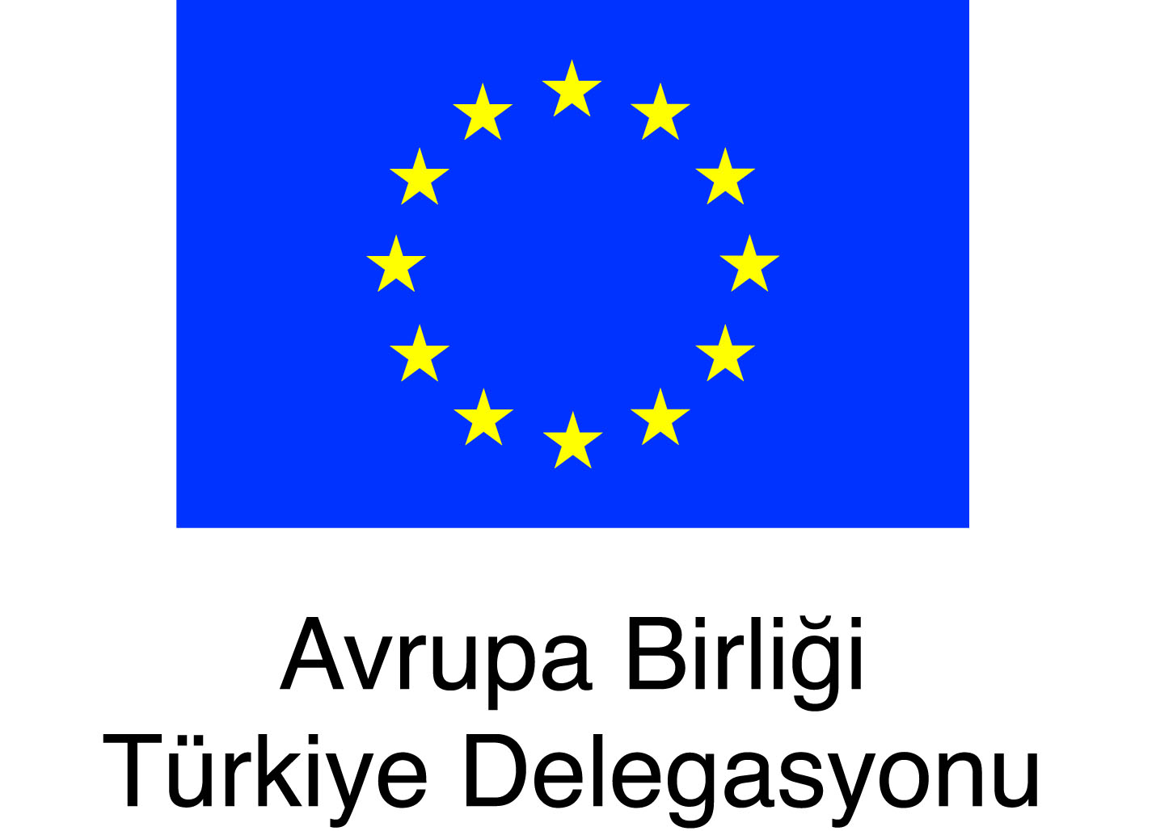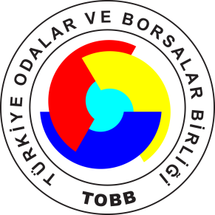

Interactive Training on “Culture of Democracy & Living Together”

The Event is organized by Ankara EU Information Center.

Venue: TOBB ETÜ Social Facilities
18th September 2015, Friday, Ankara

PROGRAM
09:30-­‐11:00 Introduction and Group Dynamic
11:00-­‐11:30 Coffee Break
11:30-­‐13:00 Democracy Village Simulation
13:00-­‐14:00 Buffet Lunch
14:00-­‐15:00 Democracy Village Simulation
15:00-­‐15:30 Coffee Break
15:30-­‐17:00 Evaluation of Simulation
17:00-­‐17:30 Final Remarks

COMPONENT OF TRAINING
Democracy & Participation
Democracy Types
Social Act
Participation Types
Social Empathy
Intercultural Dialogue
Societal Diversity
Human Rights
Social Clash (incompatibility) Management

