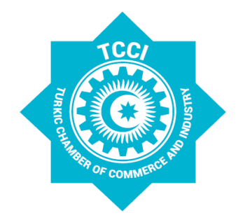

STATEMENT OF THE TURKIC CHAMBER OF COMMERCE AND INDUSTRY

Participants of the extraordinary meeting of the Turkic Chamber of Commerce and Industry (TCCI) on "A new era of social and economic development of Azerbaijan" appreciate the socio-economic progress and achievements of Azerbaijan.

In accordance with the strategic priorities set by President Ilham Aliyev for the development of entrepreneurship, continuous improvement of the business and investment climate, improvement of the legislative framework, state support for entrepreneurship, investment, modern technologies, management experience, they welcome emerging business friendly environment in the Republic of Azerbaijan that fosters economic activity, favorable conditions created for the formation of the economy; leads to the establishment of hundreds of enterprises producing competitive products, and, consequently, leads to an increase in total volume of exports to third countries.

TCCI conveys its deepest appreciation for the exceptional services and work provided under the patronage of the President H.E. Ilham Aliyev and the First Vice President H.E. Mehriban Aliyeva in improving the legal framework of economic reforms, protecting the legitimate interests of entrepreneurs and strengthening business activities that ultimately resulted in the socio-economic development of Azerbaijan.

Unity and solidarity among Turkic Speaking States that is built upon common values and shared identity is being enhanced by our joint efforts. These unique friendly and fraternal relations have become an important factor in serving peace, security and cooperation and guiding political and economic processes in the region.

The support of Turkic-speaking countries for the rightful cause of Azerbaijan is yet another manifestation of the invaluable solidarity among our peoples.

As the members of TCCI and the business community of Turkic-speaking countries, we are closely following the recent events in Azerbaijan and therefore reiterate the importance of resolving the Armenian-Azerbaijani Nagorno-Karabakh conflict on the basis of the sovereignty and internationally recognized territorial integrity of the Republic of Azerbaijan.

The participants strongly condemns the attacks of the Armenian armed forces against Azerbaijani civilian settlements far from the conflict zone, and the resulting heavy casualties among the civilian population. The international community should take necessary steps to prevent the deliberate targeting of civilians by Armenia in violation of international law and demand the withdrawal of the country's armed forces from the occupied territories of Azerbaijan.

We, the members of TCCI, express our readiness to mobilize all our resources and take part in large-scale projects that will benefit socio-economic of the liberated territories of Azerbaijan.

The participants along with the entrepreneurs of Turkic-speaking States hereby declare our full support for Azerbaijan in order to resolve this conflict. We also believe that the Turkic World would strive for new economic achievements by enhancing its competitive strength and expanding its outreach in a way to bolster our common prestige and the welfare of Turkic peoples.

The participants of the extraordinary meeting of the Turkic Chamber of Commerce and Industry that was convened with the theme of “A new era of social and economic development of Azerbaijan” in Baku, on 2 November 2020, adopted this statement.

